Abstract- In recent times, data mining techniques have been emerged and developed rapidly. In this paper, we focused on many data mining techniques such as Association rule, Clustering and Classifiers techniques to explore bank marketing data for better purpose of marketing. Clustering techniques area also used to divide the data in to their group of segments. Association rules are applied to find the relation between the attributes in a data. Dataset has been analyzed by applying Association rules to find the patterns among the attributes in a dataset. Classification Algorithms such as Decision trees and Logistic algorithms were used to classify the data and to find the classification algorithm which is performing well on the dataset.
Keywords – Association rule, Logistic regression, Bank marketing, Clustering and Decision trees

1.Introduction:
Increase in rapid technology has given birth to vast amounts of data in various sectors. Data mining techniques in this area can help in decision making. The extraction of data for decision making by using data mining concepts is called Knowledge Discovery process (Xiao, 2012). Knowledge discovery is a logical process to find the patterns in data which is hidden. These patterns are helpful in developing the marketing and business.
There are three steps 1. Exploring 2. Pattern Identification and 3. Deployment. Exploring of data contains multiple steps involved in it such as finding out the data and transforming the data in to applicable method. Pattern identification is finding out the hidden patterns in attributes and its variable and finally deployment is implementing the patterns in appropriate methods (Ahmed and Hannan, 2012).
In this model, we propose four machine learning algorithms to find the pattern and performance of dataset using Association rules, Logistic regression, decision tree and clustering models. Association rules are efficient algorithms which finds the itemset that frequently appears among vast volumes of data. This type of finding hidden patterns helps in decision making among cross marketing and customer purchasing behavior. Association rules are generated based on support and confidence having less than 1. It also generates a measure called lift to measure the performance of rule in database. Association rules are often used to reduce transaction databases and to understanding the hidden concepts in a database. (Lee and Song, 2016).
Clustering is grouping of variables based on their patterns. A group in cluster contains similar variables. Using cluster methods, we can find the correlation and distribution pattern of attributes among data. We used cluster to group the variables in our dataset because classification techniques increase cost in grouping the variables (Bharathi and Ramageri, 2010).
Finally, we used Classification techniques to predict the performance of our model. These classification techniques often employee’s decision tree and neural networks for predicting the accuracy of model and performance. We used Decision tree model and Logistic regression in our model to classify the data and analyzing the data. The further implement is to predict the performance and best model in between them. In this paper, Section 2 describes the related models and section 3 states about the cleaning of dataset and section 4 focus on the Data mining techniques used for exploring the data.

3. Data preparation and environmental setup:
Bank marketing dataset has been taken from UCI Machine Learning repository which contains multiple attributes such as Age, gender, address, loan amount, housing, education and marital status of person. It contains 45211 instances and 17 attributes in it.
Data cleaning and Data preprocessing task is important and crucial step before implementation of algorithms. It had to be make sure that dataset is clean and should not contain any missing values or duplicate values in it. We used Rapid miner for better understanding the data and RStudio for cleaning the data.
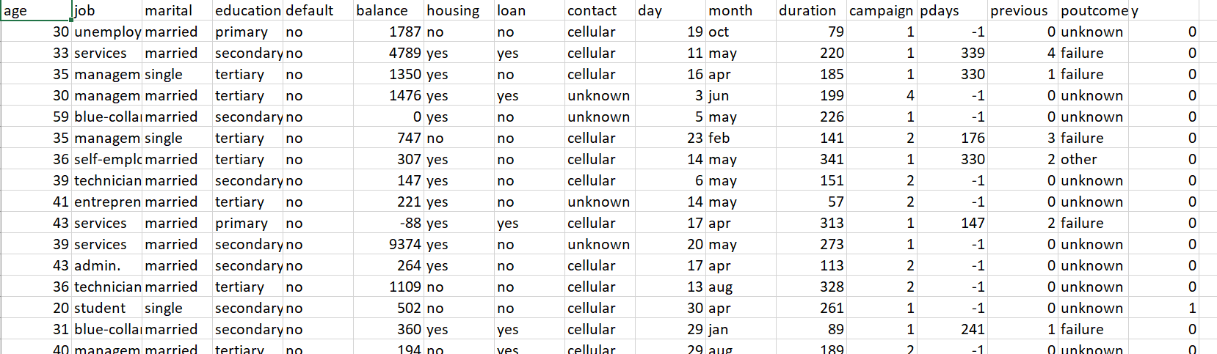
Fig no1 Dataset and Attributes

Environmental setup:
Rapid miner and RStudio are two platforms used in our Implementation. Rapid miner is a Data analytics software which consists Machine Learning Algorithms in it. It is easy to use and prominent results will be displayed. Clustering and classification algorithms are used in Rapid miner in our implementation.
RStudio is Integrated Development software which runs on programming. It expects user to provide code for respective algorithm. It includes multiple packages built in it which helps in providing the appropriate results. Apriori algorithm in Association rules is implemented in this algorithm.

4. Data Mining Techniques
a) Association rule:
Association rule mining is one of the important techniques in data mining. It finds the relation pattern between the attributes in a dataset. Association rules reduce the size of database by compressing the data. Compressing of data is done by finding relations in between. Market Basket Analysis is one of the most efficient analysis in reducing the size. Generally, Association rules gives a pattern that if A and B events occurs, then there is a likely of event C to be occur.
For example, if a customer purchases bread and jam, then there is a chance of customer purchasing butter too.
{bread, jam} -> {butter}
Implementation of Apriori Algorithm:
Apriori algorithm helps in reducing the transactional databases. It starts finding subsets from itemset by bottom up approach. It also follows Breadth first search following the iterative search of layer by layer search. (Kaung, 2010). Apriori rules are implemented in RStudio by using package called “library (arules)”. Apriori algorithm is inbuilt with most of the relation finding patterns, so that we can simply use Apriori(dataset) to execute the rules. Apriori algorithm is applied on Loan, Job, Marital and Education attributes in our dataset.
Support and confidence are passed as arguments to determine the efficiency of rule.
Support: Support can be calculated by fractioning the transaction that contain item X with total number of transactions.
Support = Number of transactions that contains item / number of transactions
Confidence: Confidence is calculated by fractioning the transaction that contains item X in Y with total number of transactions that contains X and Y.
Confidence = Number of transactions that contain x in y/ total number of transactions that contains both X and Y
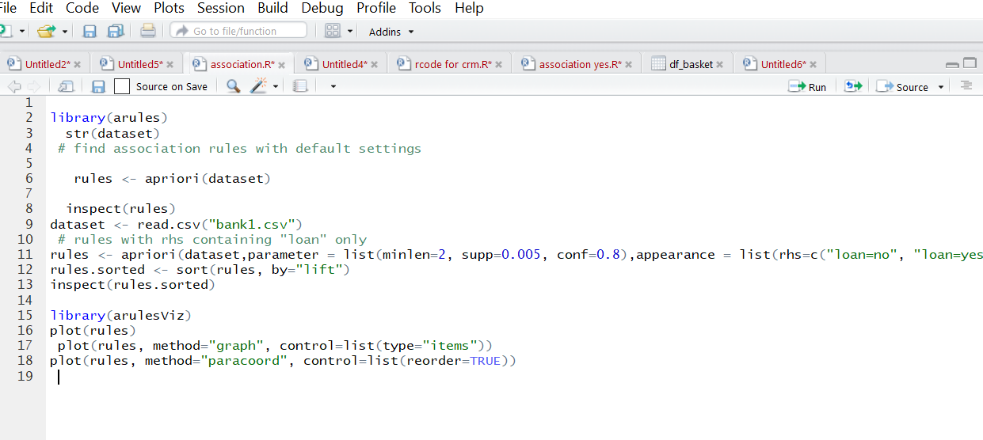
Fig 2 Apriori Algorithm
From the above figure, we can see that code for generating rules where dataset is read first by using “read.csv”. Rules are created by using Apriori (rules) and visualization of rules are done with package arulesviz.

Association rule Interpretation:
The following figures shows the rules formed by Association rules. Here, we got two outputs
- Consisting rules when loan is not taken from bank.
- Consisting rules when loan is taken from bank.

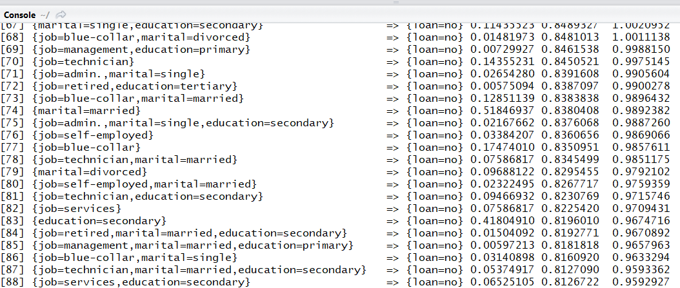
Fig no 3 Association rules for loan = No
From the above figure, we can see the list of cases where there is chance of taking no loan. By observing rule 71, we can predict that case that when job is admin and marital is single, then there is chance of taking no loan with support of 0.02 and confidence of 0.8. Similarly, other rules are stating the cases loan = no.
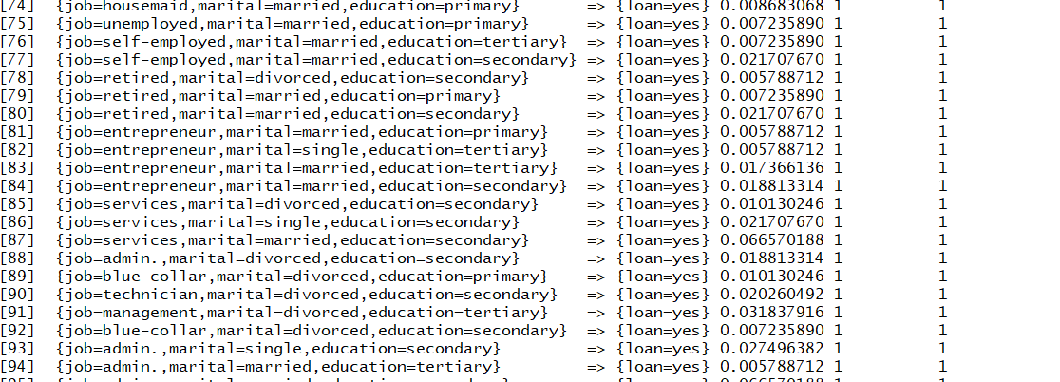
Fig no 4 Association rules for loan =yes
Fig no 4 states rules which are chances of taking loan. Rule 84 states when job is entrepreneur then there is chance of taking loan with support 0.01 and confidence of 1. Similarly, as above, all rules are directing when loan = yes.
Visualization of rules:
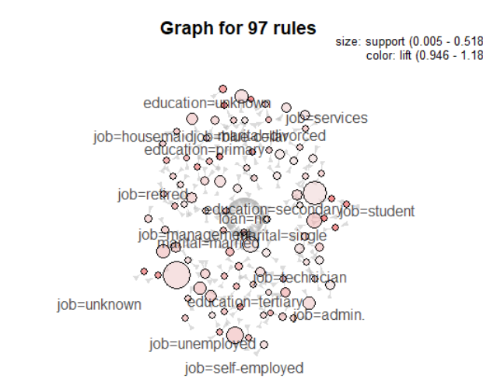
Fig no 5 Graph for 97 Rules
Above figures shows the graph for the rules created by association rules. It shows different kind of jobs that persons related to. Size of the cirlce indicates support of rule which indicates the efficiency of rule.Color of cirlce indiactes the lift of rule which is measure of rule. If the lift is high, then the occurrence of rule is high.
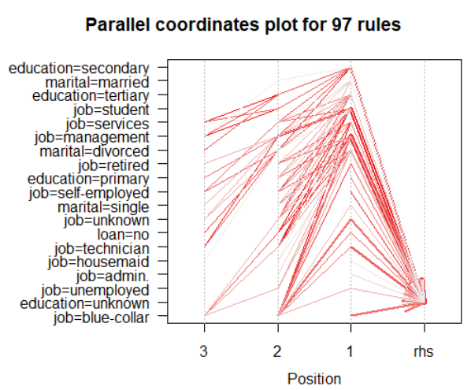
Fig no 6 Parallel coordinates for rules
The rules sorted by lift in shown in above figure. The rules which lies in plot 3 has high lift than rest of rules.
[1] Gu, X.F., Hou, X.J., Ma, C.X., Wang, A.G., Zhang, H.B., Wu, X.H. and Wang, X.M., 2015, December. Comparison and improvement of association rule mining algorithm. In Wavelet Active Media Technology and Information Processing (ICCWAMTIP), 2015 12th International Computer Conference on(pp. 383-386). IEEE.
[2] Bharati, M. and Ramageri, M., 2010. Data mining techniques and applications.
[3] Song, K. and Lee, K., 2017. Predictability-based collective class association rule mining. Expert Systems with Applications, 79, pp.1-7.
[4] Ahmed, A. and Hannan, S.A., 2012. Data Mining Techniques to Find Out Heart Diseases: An Overview. International Journal of Innovative Technology and Exploring Engineering (IJITEE), 1(4), pp.18-23.
[5] Lili KUANG. Discussion on Apriori algorithm and FP-tree algorithm. Huaibei Coal Industry Teachers College (NATURAL SClENCE EDITION), 2010, 31 (2).

